Software Requirements Specification

For The

Malaria Decision Support System

Version: 0.2

Document Status: Draft

Compiled By: Miguel Orlans

Date: 09 January 2009

Document Reference: MDSS-FSP-DOC

Table of Contents
CHANGE HISTORY 3
Configuration Control 3
Revision History 3
1. Introduction 4
1.1 Purpose 4
1.2 Document Conventions 4
1.3 Intended Audience and Reading Suggestions 4
1.4 Project Scope 4
1.5 Document Life Cycle 5
1.6 References 5
2. Overall Description 5
2.1 Product Perspective 5
2.2 Product Features 6
2.3 User Classes and Characteristics 7
2.4 Operating Environment 8
2.5 Design and Implementation Constraints 8
2.6 User Documentation 9
2.7 Assumptions and Dependencies 9
3. Use Cases 10
3.1 User Administration/Access Control 10
3.2 System Maintenance 10
3.3 Entomology Surveillance 11
3.4 Case Surveillance 11
3.5 Intervention Monitoring 14
3.6 Malaria Indicators 14
3.7 GIS 15
3.8 Stock Control 15
3.9 Intervention Planning 15
3.10 Generic Use Cases 15
4. Interface Requirements 16
4.1 User Interfaces 16
4.2 Hardware Interfaces 16
4.3 Software Interfaces 16
4.4 Communications Interfaces 17
5. Other non functional Requirements 17
5.1 Performance Requirements 17
5.2 Security Requirements 17
5.3 Software Quality Attributes 17
6. Other Requirements 17

CHANGE HISTORY

Configuration Control

Project | Malaria Decision Support System
Title | Software Requirements Specification
Document Reference | MDSS-FSP-DOC
Created By | Miguel Orlans
Creation Date | 08 January 2009

Revision History

Revision No | Revision Date | Changed By | Changes
0.1 | 23 Dec 2008 | Miguel Orlans | First Draft
0.2 | 08 Jan 2009 | Miguel Orlans/Marlize Coleman | Revision corrected for first release

Introduction

Purpose
This document comprises the functional specification of the first version of a Malaria Decision Support System (MDSS). It will be the main source of information for the development team and describes the architecture of the system, the functional modules and functional blocks and the individual use cases, as well as other information relevant to the development of the system.

Document Conventions
When describing a field, this filed could be optional, mandatory on database level or mandatory through application validation. If the field is mandatory on database level it will be indicated by (mdb). If it is mandatory through application validation it will be indicated by (ma).
Although there is a glossary of acronyms in addendum, on first use each acronym is spelt out in full.
Each functional requirement has a given priority. Should no priority be mentioned, it must be assumed that the priority is inherited by the parent functionality or module.

Intended Audience and Reading Suggestions
This document is intended for the system developers, as well as all the MDSS project members. It can further be of use to any stakeholder in the project. As the project is supported by the (South African) Medical Research Council (MRC), the Innovative Vector Control Consortium (IVCC) and the Colorado State University (CSU), this document can also be of use to related or parallel projects within these organizations, requiring systems that support vector borne disease control.
In addition to this document, further reading is suggested to conceptually understand the Chado database schema approach (http://gmod.org/wiki/Schema) and the Malaria Insecticide Resistance Ontology (MIRO)
(http://www.obofoundry.org/cgi-bin/detail.cgi?id=mosquito_insecticide_resistance).

Project Scope
The MDSS can assist countries world-wide to proactively and reactively address malaria risk and control. Currently malaria mortally figures reach in the range of a million people annually Malaria elimination is currently a priority for many areas and malaria information systems need to be critically reviewed to ensure they are suitable for this purpose. Malaria elimination is currently a priority and topical issue for many malaria effected areas and information systems need to be critically reviewed to ensure they are suitable for this purpose. The MDSS will be a suitable system capable of managing a variety of transmission settings.

A usable release of this system must be ready for roll-out to three countries by the end of June 2009 (rigid deadline). The three countries (Mozambique, Zambia and Malawi) currently have spreadsheet and MS Access based tools and established but disparate processes and procedures. The system needs to be generic to a degree, but able to support the different needs in different countries. This pilot implementation will be unsuccessful if the countries are not given a system with at least the functionality they are currently familiar with, and in addition a simple GIS functionality, which has been identified as a common need.
MDSS will be a living system, to be enhanced with additional modules and functionality, and can be rolled out to other countries in Africa, as well as South America and Asia.

Document Life Cycle
This document is subject to revision control and will be updated on a regular basis as the project progresses. Please ensure that you are working with the latest release at all times.

References
- Product Description MDSS (Mike and Marlize Coleman)
2-MDSS_Product_description.doc
- Conceptual document MDSS detailed background document on current activities in the pilot countries
(Mike and Marlize Coleman)
4-MDSS Conceptual Document.doc
- Suggested database schema for MDSS (pending)
- overview of the Chado ontology schema
http://gmod.org/wiki/Introduction_to_Chado

Overall Description

Product Perspective
MDSS is a new product, loosely based on disparate existing tools in a variety of countries. It will be built from scratch and will be released in June 2009 as MDSS V1.0.

After June 2009 MDSS V1.0 will be the basis for further development of the MDSS system, as well as the expansion to other vector borne disease control systems, specifically dengue, currently contributing to the planning and development of the MDSS. Certain specifications might go beyond the scope of the current MDSS project.

Product Features
The system is modular and needs to cover the functionality as depicted in the following diagram:
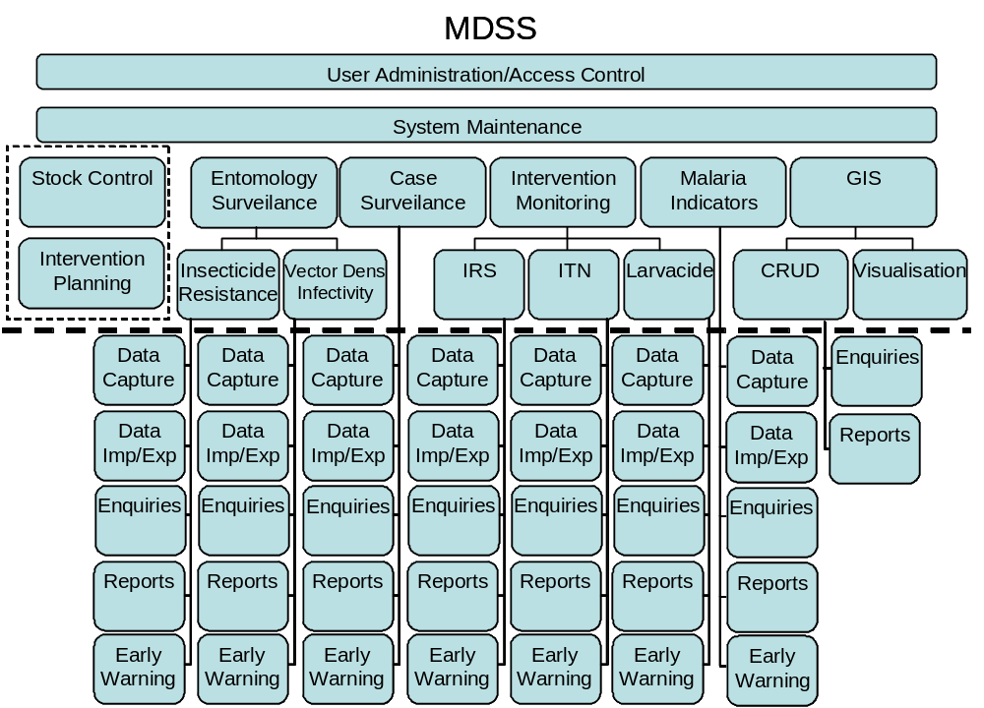
Figure 1: Functional breakdown of MDSS

The User Administration/Access Control Module will allow an administrator to create user profiles, add users, allocate profiles to users and override (add or retract) certain permissions on a user level. It should be possible to allocate several profiles to a single user (not a mandatory requirement for phase 1). The User Profile will also determine the menu structure available to the user.

The System Maintenance module will allow Maintenance Users to add or remove certain values to lookup tables. It will be specified in this document what the implications for such actions will be. Typically existing records will not be updated and will retain the value that has now become defunct. Any thresholds or other configurable parameters will also be accessible through this module. Ideally, certain captions and labels will also be configurable. An example of this is the capturing of a location. The location table will have a multitude of address fields (e.g. Address1 – Address10), but these fields will have different meaning depending on the country where the system is deployed, and the type of location (sentinel site, patient address… ). Therefore the captions on the user screens should be configurable. Since the system needs to support multiple languages, all text will be stored in an accessible file or table in any case.

Entomology surveillance deals with the collection of mosquitoes at different sites using different methods and determining the quantities of different mosquito species (Vector Density) and the ratio of mosquitoes infected with the malaria parasite (Infectivity). In addition, field and laboratory tests are performed to establish the mosquitoes’ susceptibility is to different insecticides (Insecticide Resistance). This module in particular, but also other modules, will make use of the MIRO ontology. MDSS will allow the capturing of this data and will assist in the analysis of the data and provide early warning indicators and suggestions as to what intervention is required.

Case surveillance will deal with patients who have been diagnosed with malaria. These could be passive cases (patient goes to a medical facility on own initiative) or active cases (public health initiative to survey a population of local inhabitants, usually prompted by an index case). These cases can be captured into the system on a case by case basis, or as aggregated data. Pregnant women and children under five years old are of particular interest. The analysis of this case data will, amongst others, assist in identifying outbreaks and determine risk areas for disease stratification. MDSS should automatically, as cases are entered into the system, provide outbreak identification and notification based on defined thresholds and historical data.

Intervention monitoring currently deals with information introduced into the system as a result of intervention activities. These activities include Indoor Residual Spraying (IRS), Insecticide Treated Nets (ITN) and Larvaciding. The focus of this module is currently to record which areas have been treated and monitor treatment progress, as well as comparing the results to previous years. A complication here is that different countries have different approaches. One country focuses on daily results per spray operator, another on daily results per team and the third works on households per day. The system must cater for all three approaches (this will be detailed in the use cases). A valuable part of any malaria decision support system but mostly neglected is planning and resourcing (human resources, equipment and consumables) of interventions, but this functionality within the MDSS, depending on complexity, might be referred to a later phase.

The Malaria Indicators module focuses on a household questionnaire and the prevalence of disease at a specific point in time. Data are used to determine status and progress towards set goals. This module differs from the case surveillance module as malaria case data are collected and entered into the system annually rather than continuously.

The GIS module will allow the system to collate all the data by geographical location and time and depict this visually by means of thematic maps. The pilot countries highlighted this functionality as a very useful tool for future utilization.

The system must be language independent, as translations into Portuguese, French and Spanish are envisaged. Portuguese will be required with the pilot system in June 2009.

The intention is to add two additional modules to MDSS: Stock Control and Intervention Planning. It would be desirable to have the absolute basic functionality implemented in phase one (June 2009). Some use cases may refer to this.

User Classes and Characteristics
Within the scope of the pilot implementation, the following roles will be required:
- MDSS Coordinator
- Data capturer
- Manager
- Entomologist
- Partner
- Data extractor
- Operational manager

Operating Environment
It is envisaged that the system will most often be implemented on a stand-alone PC with an MS Windows operating system. In addition there will be sites where a multi-user configuration will be implemented with MS Windows clients and server. However, as the project cannot control the environments of the Health Ministries in all the involved countries, it is desirable to have a platform independent solution.

It is not strictly necessary to use a browser front-end, but this has certain advantages (ease of development, easy remote access, easy system upgrades… ) so it is desirable. The suggested architecture is as follows:

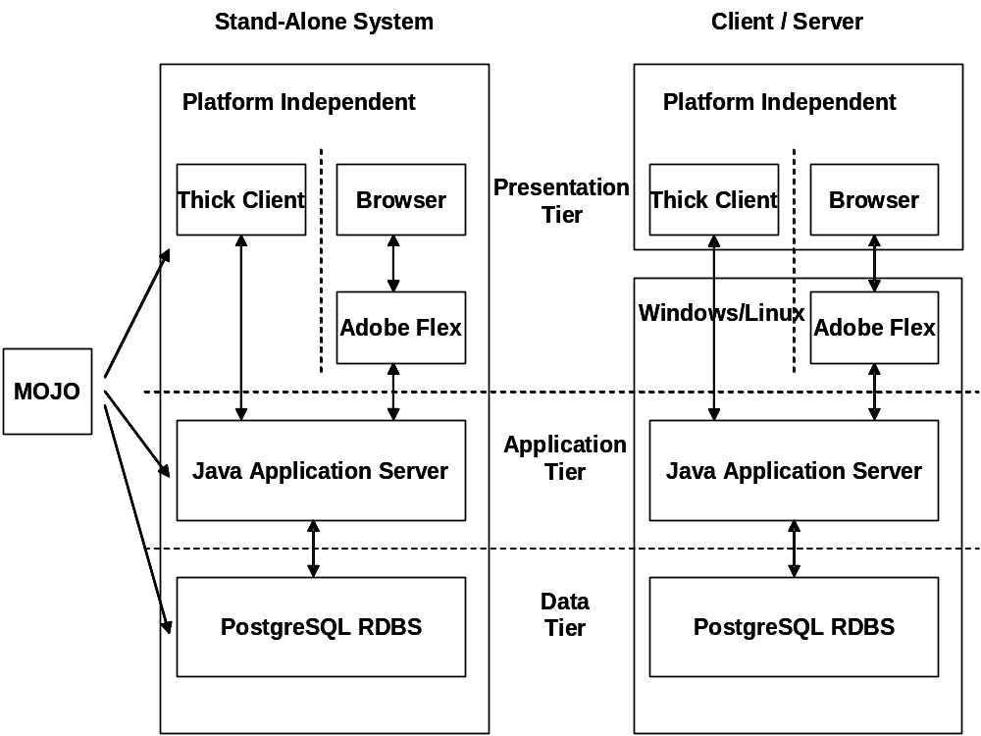

Figure 2: Suggested System Architecture

Design and Implementation Constraints
The system will be deployed in developing countries, in uncontrolled environments. The infrastructure will not be robust and the system hardware specifications will not be high-end in all cases. System support will not be readily available. The PC literacy of most of the users will be low.
This implies that the stand-alone implementation must be simple and maintenance free, and that heavy transaction processing should be avoided. System backups (typically to CD, DVD or external hard drive) should be very easy, i.e. select a menu item ‘Backup Data’ and everything else is automated. The same will be true for any data exports.

Given the context of MDSS, the User Interface must be exceptionally intuitive and simple. Some modules such as User Administration and System Maintenance will be used by ‘Super Users’ who will have a background in IT, so these areas are more flexible. The most complex User Interfaces will be the creation of custom queries and reports. This functionality will be available to all, but the use of it will be up to their discretion. Standard users will typically only have access to static enquiries and reports.

User Documentation
The project will not be successful if adequate user manuals are not developed. The Use Cases will provide the basis of the documentation and this will be elaborated on by the project members. Translation into Portuguese is highly desirable before the project goes live with the pilot implementation in Mozambique. The use of visual aids and examples are recommended with more elaborate tools to be added in phase two for example voice over slide shows.

Assumptions and Dependencies
It is assumed that the project will have access to the following data/information at the very early stage of the project (January 2009):

- Data import formats for all the different types of required data imports in the three countries;
- Sample data capture forms currently used in the target countries;
- GIS data for the three countries, to be sourced from the MRC and
- GIS functional specification of the existing system(s) in use by the MRC.

It is further assumed that the Project Manager of the MDSS development sub-project (currently Marlize Coleman) has the final approval authority of the functional specifications.

Use Cases
Use cases are organized by functional modules and functional blocks (functional hierarchy). However, since a lot of functionality will be repetitive, referrals will be made to previously defined use cases where appropriate. Flow charts are only used when the workflow is too complex to describe in a simple written, step by step narrative.

Each use case is allocated a priority from 1 to 5, 1 being the highest priority. Any use case with priority 1 must be implemented before the pilot implementation in June 2009. Other use cases are implemented in order of priority, unless this contravenes the logical build sequence to such an extent that it puts at risk higher priority functionality (i.e. if postponing the development of a priority 4 feature puts at risk a priority 2 feature, than the priority of the former feature is automatically escalated to priority 2). This needs to be managed by the development team.

User Administration/Access Control

System Maintenance
Use Case: MDSS100 (priority 1) V0.1

Name: Configuration of the import interfaces

Context: MDSS – System Maintenance – Import Interfaces – Configuration

Description:
The MDSS Coordinator configures the data import interfaces. This Use Case is generic for all the data import interfaces. There will be one import interface defined for each data capture screen that exists in the system.

Primary Actor: MDSS Coordinator

Preconditions:
The actor has logged onto the system and is looking at the MDSS – System Maintenance – Interfaces – Configuration.
A sample import file (.xls) is available.

Postconditions:
The import interface configuration is saved and associated with the ‘Import’ menu item applicable to that particular data context.

Basic Flow:
- The actor chooses (pick list) which data context he is configuring (e.g. aggregated case data).

- The actor browses for the file location of the sample data file to be imported.

- The system reads the header record and lists the field values of the header record on the screen.

- The system displays the named fields that are available in the related manual data capture field.

- The actor maps the header fields of the sample file to relevant MDSS data fields.

- The actor saves the mapping.

- The system creates the appropriate data import interface and links it to the associated ‘Import’ menu item.

Sequencing:
Sequencing will be exactly as outlined above.

Validations:
Upon ‘Save’, the system will check that any mandatory MDSS data fields have been mapped or will display an appropriate error message and refuse to save.
It will be possible to leave sample file header fields and optional MDDS data fields unmapped.

Special Requirements
None

Frequency of Occurrence: Ad hoc, infrequent.

Related Use Cases:
All data capture Use Cases:
MDSS001: MDSS – Cases – Individual – Data Capture
?
?
?

Miscellaneous:
- Data import interfaces can be reconfigured by repeating this Use Case

Questions/Topics to research:

Entomology Surveillance

Vector Density

Vector Infectivity

Insecticide Resistance

Case Surveillance
Use Case: MDSS001 (priority 1)

Name: Capture individual case information

Context: MDSS – Cases – Individual – Data Capture

Description:
A data capturer at a facility (clinic, hospital…) or district office enters the relevant information of an individual patient who has been diagnosed with malaria. The system determines whether this is a new case or an existing case, and creates the appropriate instance (visit specific information).

Primary Actor: Data Capturer at a facility or district office.

Preconditions:
The actor has logged onto the system and is looking at the MDSS – Cases – Individual – Data Capture screen.

Post conditions:
The data of an individual case/instance is stored in the system and the actor is returned to step 1 of this use case.

Basic Flow:
- The actor chooses (tick box) whether this is an active or passive case (ma)
- The actor enters the following information:
  - Date of notification (date that the form was completed) – dd/mm/yyyy – supply calendar. If the date is not entered when the data is committed the system will generate the date as current.
  - If it is a passive case, the name of the facility (from a pick list) or facility reference. Either one will result in the other one being populated automatically by the system. Show facility category and locality as part of the pick list to simplify the choice as a hospital and clinic can have the same name (ma).
If it is an active case, the facility fields are not available.
  - Patient name, surname, age or birth date (dd/mm/yyyy – use calendar). The one entered will populate the other. If an age is entered, the birthdate will be calculated as follows: today - age. Birthdate is stored in the ‘person table’ age is stored in the ‘case’ table
  - Gender (tick box).

- The system looks up any cases with similar surname – age – gender combinations entered in the previous 4 weeks.
- If one or more matches are found,
- more information is displayed – name, residential details, facility, diagnostic date of last instance of this case.
- The actor has the option to terminate data entry because it is a duplicate form from the same facility
- The actor gets the opportunity to create a new ‘instance’ against this case.

- If no match is found or the actor chooses not to create a new instance, the system creates a new case and a first instance against the case.

- If this is a new case, additional patient location data must be captured, i.e.
  - Residential location.
  - Work location
  - Infection/source location
Each can be selected by a tick box. For each tick box selected, three additional fields are displayed:
  - Locality (see generic location information: MDSS101) (ma)
  - Street – as the actor enters the street name, a scroll box shows any matching street names in the same locality and the actor can pick one.
  - House number

- The actor then enters the following information (instance specific):
  - Patient category (in patient or out patient) (tick box)
  - If in patient, date admitted and date released dd/mm/yyyy – supply calendar
  - Did the patient default (leave before release date) (yes/no) (tick box)
  - Patient has anaemia? (yes/no) (tick box)
  - If female, is the patient pregnant? (yes/no) (tick box)
  - Did the patient die? (yes/no) (tick box)
  - Was the patient referred to this facility (yes/no) (tick box)
  - Did this facility refer the patient to another facility? (yes/no) (tick box)
  - If so, what was the reason for referral (complicated case, pregnant, under 1 year old, drug stockout, Other) (pick list)
  - Test type (blood smear, RDT, clinical or other) (pick list)
  - Test date dd/mm/yyyy – supply calendar
  - Date diagnosed dd/mm/yyyy – supply calendar
  - Treatment method (tablets, syrip, IV, IM or Other) (pick list)
  - Treatment administered (LA, AA, AS+SP, Cloroquine, Quinine, No treatment or Other) (pick list)
  - Treatment date dd/mm/yyyy – supply calendar
- The system will also record against the instance, the data entry date, the actor’s name and surname and whether this is an active or passive notification .
- Upon entering the information all the data is committed (patient, case, instance) and a threshold comparison against the source/infection location for the locality is performed as follows: Sum all cases for the epiweek (see MDSS??? : Configuration of epi-week) for the specific source/infection location and compare the value to the predefined thresholds (2 thresholds, 1 alert 1 identification) for that week.
The threshold values must be configurable by the system administrator.

Sequencing:
Step 1 input sequence must allow step 2 validation.
If the case is new, patient information must be entered before continuing (step 3).

Validations:
  - Age must be between 0 and 110. 0 implies an age less than 1
  - Date admitted must be before date released
  - Test date must be equal or before date diagnosed
  - Date diagnosed must be equal or before treatment date
  - A male patient can not be pregnant
If the validation fails, a pop-up screen notifies the user why the validation failed and is asked to click on ‘OK’. He is then returned to the same field where the original entry is still displayed, but highlighted. Subsequent data entry will automatically replace the original data entry.

Alternate Flow 1 – Threshold exceeded:
If the sum to be compared against the threshold, as calculated in step 6 exceeded or is equal to the threshold, then:

A pop up occurs. The pop-up will state the alert or identification status plus the sum and threshold values.
The same information will automatically be e-mailed to specified addresses after the pop-up is closed (Priority4)

Alternate Flow 2 – Actor tries to quit the screen before data input is completed or before committing the data:
A pop-up screen warns the actor that the information is not complete and/or has not been committed. Does the actor really want to quit?

Alternate Flow 3 – Actor tries to commit the record without all fields complete; A pop-up screen warns the actor that the information is not complete no matter if the field is mandatory or not. Does the actor really want to commit the incomplete record?

Special Requirements
None

Frequency of Occurrence: Continuously

Related Use Cases:
MDSSyyy – Capture facility
MDSSqqq – Handling locational data
MDSS??? - Configuration of epi-week

Miscellaneous:
- This use case assumes that the generic location data exists in the system . Facilities are captured in another screen, probably under system administration (MDSSyyy).
- The system needs to understand the (country specific) epi week concept. It must either store the epi week with each date, or be able to calculate it on the fly (preferred method)

Questions/Topics to research:

Intervention Monitoring

IRS

ITN

Larvaciding

Malaria Indicators

GIS

CRUD

Visualisation

Stock Control

Intervention Planning

Generic Use Cases
Use Case: MDSS101 (priority 1) V0.1

Name: Enter generic location information

Context: MDSS – Generic – Location – Data Capture

Description:
The actor selects the appropriate geographic information associated with data capture he is performing. This Use Case is generic to any screen where location information is input or updated.

Primary Actor: Any data capturer.

Preconditions:
The actor is using a screen where location data is required.
All the Generic Location data has been populated in the relevant tables.

Postconditions:
Generic location data is associated with the record that the actor is creating or updating in his input screen.

Basic Flow:
- The actor selects the ‘Locality’ field and starts to type the name of the locality.

- After typing each letter, a scroll box shows localities that are in the system and start with the entered characters, appended by ‘, ‘ and the name of the geographic entity that is one level higher than the locality. The actor can select the relevant locality from the scroll box.

- The system will use this locality – ‘one level higher’ combination to find the geographic entity ID in the geographic ontology.

- The system must store this entity ID in the appropriate table and associate it with the other data that the actor is entering (e.g. patient or spray activity).

Sequencing:
None

Validations:
None

Special Requirements
None

Frequency of Occurrence: Continuously.

Related Use Cases:
All data input Use Cases:
MDSS001: MDSS – Cases – Individual – Data Capture
?
?

Miscellaneous:
- Localities are identified in the geographic entity table by an ‘is_a locality’ relationship.
- It is assumed that the locality – ‘One level higher’ combination is unique. This implies that there should be validation defined where this data is entered.

Questions/Topics to research:

Interface Requirements

User Interfaces
This document will not detail the User Interface any further. Additional documents might be created to define screen layouts and menu structures, but a lot will be left to the discretion of the developing team. The language of the User Interface will be driven by the user’s locale.

Hardware Interfaces
MDSS needs to be able to print reports and enquiry results to any configured printer. In addition MDSS must backup and export data to storage devices attached to the system (typically CD/DVD, but also memory sticks or other). At a later stage, MDSS will accept input data directly from PDAs.

Software Interfaces
At this stage is not clear whether or not MDSS will interact with other distinct applications such as a report writer or third party GIS system. This will depend on the tools that the development team chooses to best implement the specifications as defined in this document. It is known that MDSS will need to import data from MS Excel. The import format will vary dramatically, so a generic, configurable upload tool has been defined in Use Case MDSS101. Automated alerts via email or mobile/cell by sms/txt message must be possible.

Communications Interfaces
Currently there are no communication interfaces defined. Especially if the implemented solution uses a browser front-end, there are none envisaged. Possibly at a later stage data transfer will be automated using FTP, but given the poor infrastructure in developing countries that is not likely.

Other non functional Requirements

Performance Requirements
As MDSS is not a transaction processing system (TPS) and remote access is not a high priority, there are no specific performance requirements. As a rule, a response time (screen update) of 1-3 seconds is desirable. Response times of more than 5 seconds are not acceptable (with the exception of some user created queries).

Security Requirements
??

Software Quality Attributes
The most important quality attribute of MDSS is the configurability of the system by the system administrators. Any configurations done on-site must be recorded in structured configuration files so that later upgrades of MDSS can integrate any local configurations automatically during installation.

Other Requirements
MDSS must make extensive use of locales. It will be deployed in different countries and different continents and this will not only affect the User Interface language but also a host of other variables which are detailed in appendix B.

Appendix A: Glossary of Acronyms
Chado: Chado is not an acronym. It refers to the background of the creation of the Chado schema and is associated with a Japanese tea.

CSU: Colorado State University. A member of the IVCC.

GIS: Geographical Information System. Subsystem of MDSS, providing specific spatial graphical and textual information.

IRS: Indoor Residual Spraying.

ITN: Insecticide Treated Nets. Nets placed at selected households to stop and kill mosquitoes entering the household.

IVCC: Innovative Vector Control Consortium, comprising five institutions worldwide, dedicated to assist in the global control of insect borne infectious diseases.

MDSS: Malaria Decision Support System. The system under development, which will ultimately assist more than 100 countries to control malaria outbreaks worldwide.

MIRO: Malaria Insecticide Resistance Ontology. A valuable ontology that will be used extensively within MDSS.

MRC: (South African) Medical Research Council. A member of the IVCC.

TPS: Transaction Processing System. Refers to systems that specialize in processing huge amounts of transactional data.

Appendix B: Locale
User language (menus, screens, help files…): Any displayed text (except data content) must be configurable in translation tables. According to the locale, the correct value is displayed.
Epi week: there are up to 53 epi weeks in a year. Week 1 starts on a specific date and week 2 starts exactly one week later. The only difference per locale is the start date, which could be a few days back into the previous calendar year, or a few days into the current calendar year. This depends on the day of the week that an epi week commences. Epi week values could be stored in the database if the development team considers this appropriate. Otherwise it can easily be calculated, but this calculation is locale dependent. Take into consideration that data in the system can be several years old and the epi week must still be available.

Appendix C: Issues List
Need tools for GIS: GIS will integrate with all the other modules, so it is not a standalone module at all. Examples are:
Intervention planning - by clicking on an area the system will instantly show how many households/structures are involved, how big the team must be to spray over a specified time in a specified area and how much insecticide is required. Once intervention has started, an instant visual representation with different colors for different % complete per area can be shown
Case data: If a threshold of malaria cases is exceeded, this can be shown graphically per area.

Need a basic stock control module. This will be a very basic system in phase 1: stock in/out per stock item. Calculate current stock. Keep track of or calculate days or weeks out of stock per item. At a later stage this will include order processing and accounting.

Need a basic intervention planning module that will integrate with the intervention module and the stock control module.

Need to create graphs as part of reports or online enquiries.

Need a flexible reporting tool, preferably integrated into MDSS so that power users can create reports and save them as static reports in MDSS for all users to view.

How do we best handle the different requirements in different countries without writing three systems?

